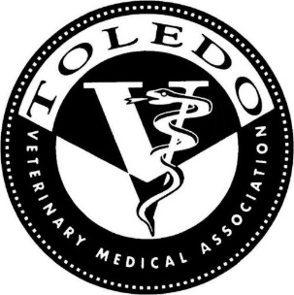
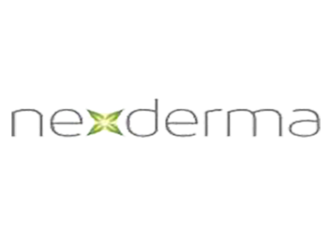
The Toledo Veterinary Medical Association and Nexderma
invite you to join us for a dinner meeting on
Tuesday October 15th, 2019
“The Treatment of Wounds and Dermatology Issues with
Silver and Stem Gel”
Our Host: Dana Colbert, Executive Director of Nexderma
Location: Souk Mediterranean Kitchen
139 South Huron Toledo, Ohio 43609
Time: 6:30 registration / 7:00 Dinner and Presentation

Please RSVP to Jeffrey Serve’, Director of Business Development, Nexderma
at either 419-509-2242 or by email at Jeffs@nexderma.com
Join us for a menu of Mediterranean dishes along with old world Italian Cuisine

